**DAILY ONLINE ACTIVITIES SUMMARY**

|  |  |  |  |  |
| --- | --- | --- | --- | --- |
| **Date:** | 10/07/2020 | **Name:** | JASLINE SHARON TAURO | |
| **Sem & Sec** | 4th sem,  A Section | **USN:** | 4AL18CS029 | |
| **Online Test Summary** | | | | |
| **Subject** | OBJECT ORIENCTED PROGRAMMING | | | |
| **Max. Marks** | 30 | **Score** | N/A | |
| **Certification Course Summary** | | | | |
| **Course** | Salesforce User Basics | | | |
| **Certificate Provider** | Sales Force | **Duration:** | | 3 hrs |
| **Coding Challenges** | | | | |
| **Problem Statement:**   Write a Java program to find the Nth natural number with exactly two bits set. | | | | |
| **Status:** | | Executed | | |
| **Uploaded the report in GitHub** | | YES | | |
| **If yes Repository name** | | <https://github.com/jaslinesharontauro/JAVA_Prgms> | | |
| **Uploaded the report in slack** | | YES | | |

**Online Descriptive Test Details:**

**Today we had test in “OBJECT ORIENTED PROGRAMMING” subject. The assessment was based on first module of this subject. The test was of descriptive type which consisted of FOUR questions of 7.5 marks each.**

**Certification Course Details:**

# Today I started the new course “Salesforce User Basics” by Sales Force. Today I learnt about how to organize the data and how to deal with bugs.

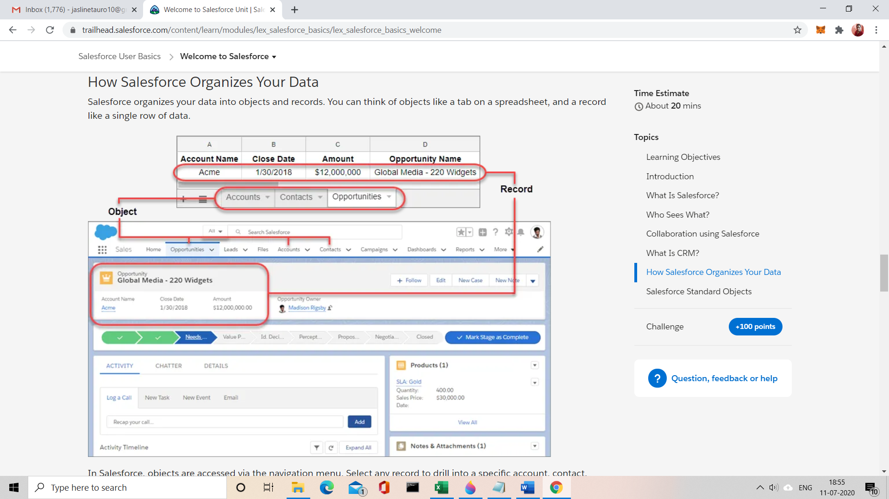

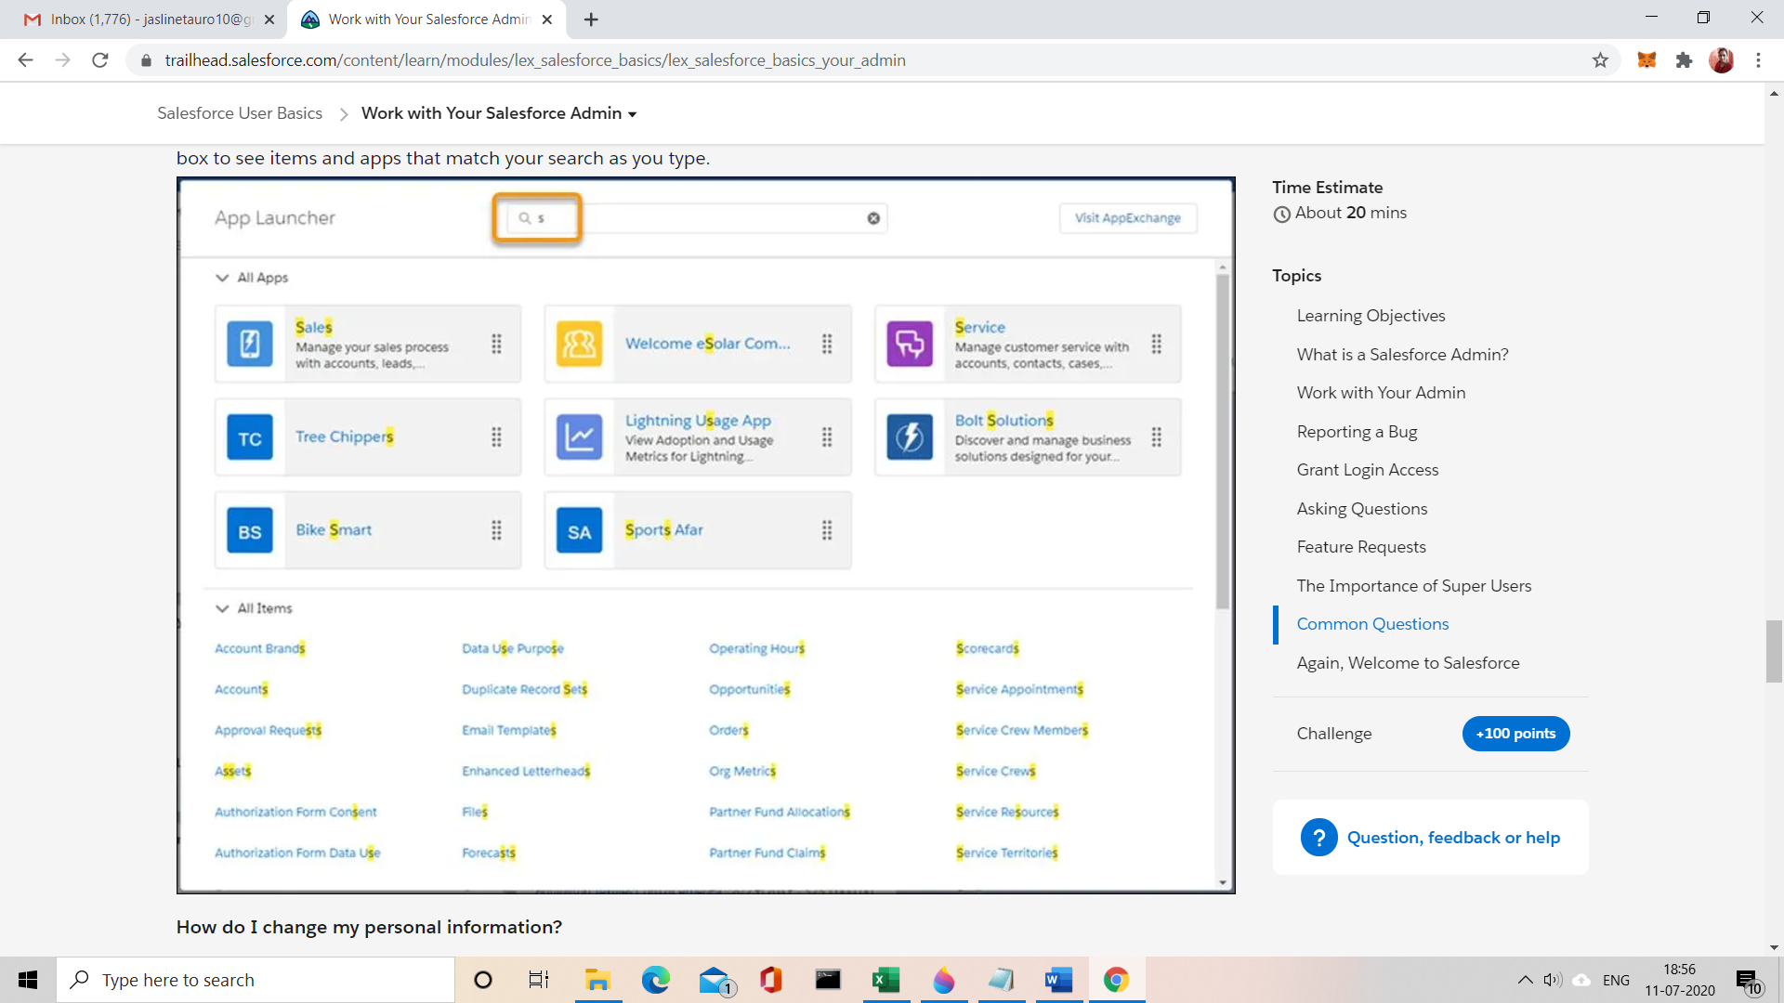

CODING CHALLENGES:

Problem Statement:

Write a Java program to find the Nth natural number with exactly two bits set.

Given an integer N, the task is to find the Nth natural number with exactly two bits set.

**Examples:**

Input: N = 4  
Output: 9

Input: N = 15  
Output: 48

**Hint**  
Explanation: of 1st example  
Binary representation of numbers 1 -0001, 2- 0010, 3- 0011, 4-0100, 5-0101, 6-0110, 7- 0111, 8-1000, 9 - 1001, 10- 1010 etc. Here only for the bold numbers binary values contains exactly 2 bits 1's hence  
Numbers with exactly two bits set: 3, 5, 6, 9, 10, 12, …  
4th number in this is 9.

Therefore, output is 9

Solution uploaded in GitHub

